Name: Date:
Missing Word Sentences
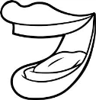
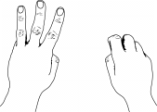
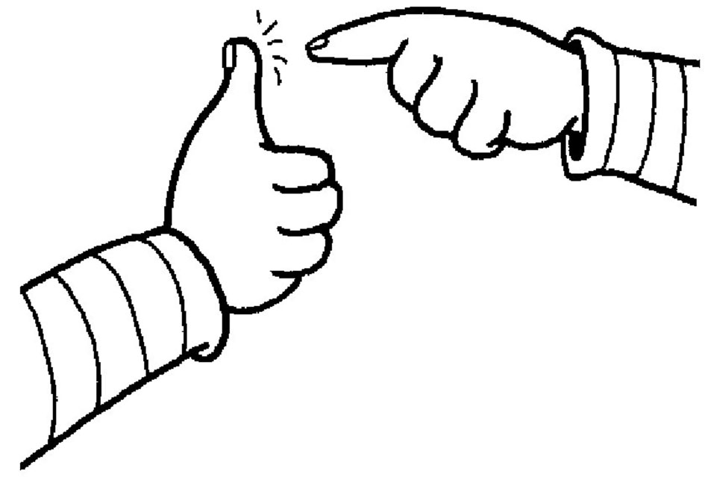
ouch mouth count pound
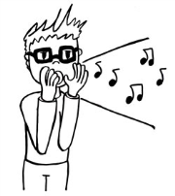
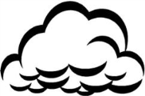
out round cloud shouts

- The teacher ___________ when we are too loud.
- Sam has a big, red, ___________ balloon.
- Rain comes from a ___________.
- My dad gave me 1 ___________ to buy a pen.
- Do not talk with food in your ___________.
- I can ___________ by fives up to 100.
- ___________! I pricked my leg with a pin.
- The teacher said, “Take your things ___________ of your bag”

